3.4 Giant covalent structure
Name: ____________________ Class: ____________________ Due date: 10.17
1. Slate has a layered structure and can easily be split into thin sheets.
Which diagram shows a structure most like that of slate? （ ）
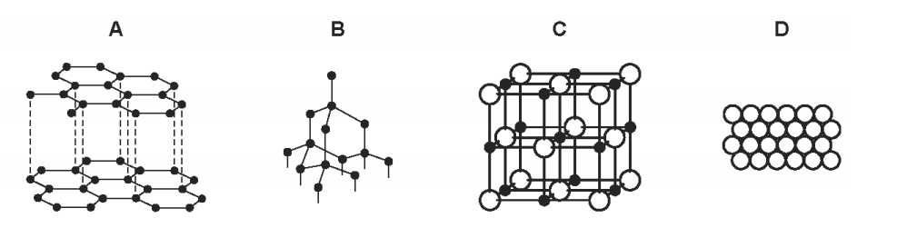
2. The diagrams show the structures of two forms, P and Q, of a solid element.
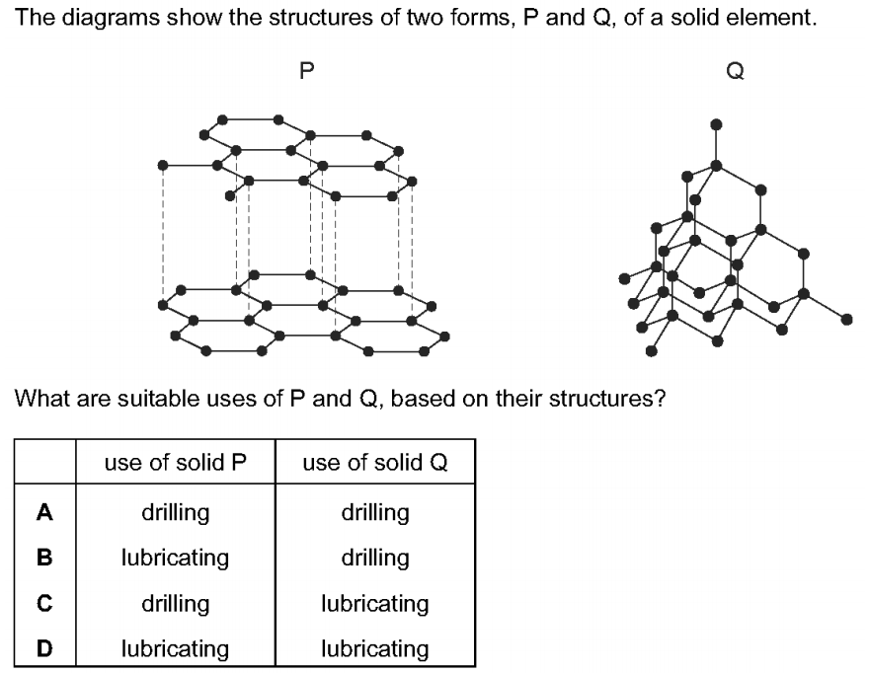
What are suitable uses of P and Q, based on their structures? （ ）
3. - (0620- S 2014- Paper 1 (Core)/3- Q5) - ATOMS COMBINING
The ‘lead’ in a pencil is made of a mixture of graphite and clay.
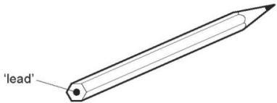
When the percentage of graphite is increased, the pencil slides across the paper more easily.
Which statement explains this observation? （ ）
A Graphite has a high melting point.
B Graphite is a form of carbon.
C Graphite is a lubricant.
D Graphite is a non- metal.
4. Graphite and diamond are both forms of the element carbon.
Which row shows the number of other carbon atoms that each carbon atom is covalently bonded to in graphite and diamond? （ ）
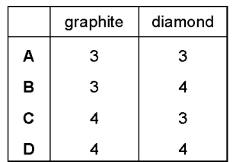
5.- (0620- S 2015- Paper 1 (Core)/1- Q6) - ATOMS COMBINING
The following statements were made about the materials used for the drill tip and the lubricant and the reasons for their use.
1 Diamond was used for the drill tip as it does not conduct electricity.
2 Diamond was used for the drill tip as it is very hard.
3 Graphite was used as the lubricant as it conducts electricity.
4 Graphite was used as the lubricant as it is soft and flaky.
Which statements are correct? （ ）
A 1 and 3 B 1 and 4 C 2 and 3 D 2 and 4
6. - (0620- S 2015- Paper 1 (Core)/2- Q6) - ATOMS COMBINING
Graphite is a form of carbon.
Why can graphite be used as a lubricant? （ ）
A Graphite contains delocalised electrons which move throughout the structure.
B Graphite contains weak covalent bonds so the atoms move easily.
C Graphite has a low melting point so it easily turns into a liquid.
D Graphite has weak forces of attraction between layers so they can move.
7.- (0620- S 2015- Paper 1 (Core)/3- Q6) - ATOMS COMBINING
Diamond and graphite are both macromolecules.
Which statement is not correct? （ ）
A Diamond and graphite contain carbon atoms only.
B Diamond and graphite contain charged ions.
C Diamond and graphite have high melting points.
D The atoms in diamond and graphite are held together by covalent bonds.
9. This question is about elements and compounds.
(i) Some properties of graphite, oxygen and carbon monoxide are shown in Table 3.1.
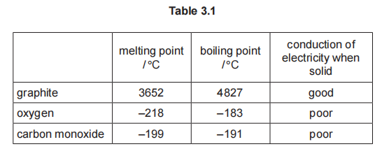
(i)Explain why graphite conducts electricity when solid.

(ii) Deduce the physical state of carbon monoxide at –195°C. Use the data in Table 3.1 to explain your answer.
Physical state .
explanation

(iii) Explain in terms of structure and bonding why graphite has a much higher melting point than carbon monoxide.

(iv)Explain in terms of structure and bonding why graphite is slippery and soft.

10.(i) Describe the structure and bonding of diamond.

(ii)Explain in terms of structure and bonding why diamond is hard.

